**ASSIGNMENT-2**

**Topic: STATITICS**

**Instructions**

1. Complete the following tasks and paste the links of the relevant pages in the space provided.

2. Upload this document after pasting the relevant links for evaluation.

3. Make sure to watch the related video lessons before attempting the tasks.

**Tasks**

**Question:**

You have been provided with a dataset that contains the following columns: 'Group', 'Score'. The 'Group' column represents the group to which a participant belongs, and the 'Score' column represents the score obtained by the participant. Your task is to perform the following steps:

* Load the dataset into a Pandas DataFrame.
* Calculate the mean, median, and standard deviation of the scores for each group.
* Perform a one-way ANOVA test to determine if there are any statistically significant differences between the means of the groups.
* Print the summary statistics (mean, median, standard deviation) for each group and the result of the ANOVA test.

Group, Score  
A,45  
A,48  
A,50  
B,53  
B,55  
B,58  
C,60  
C,65  
C,70

**Paste your code and output screenshot**

**Answer**

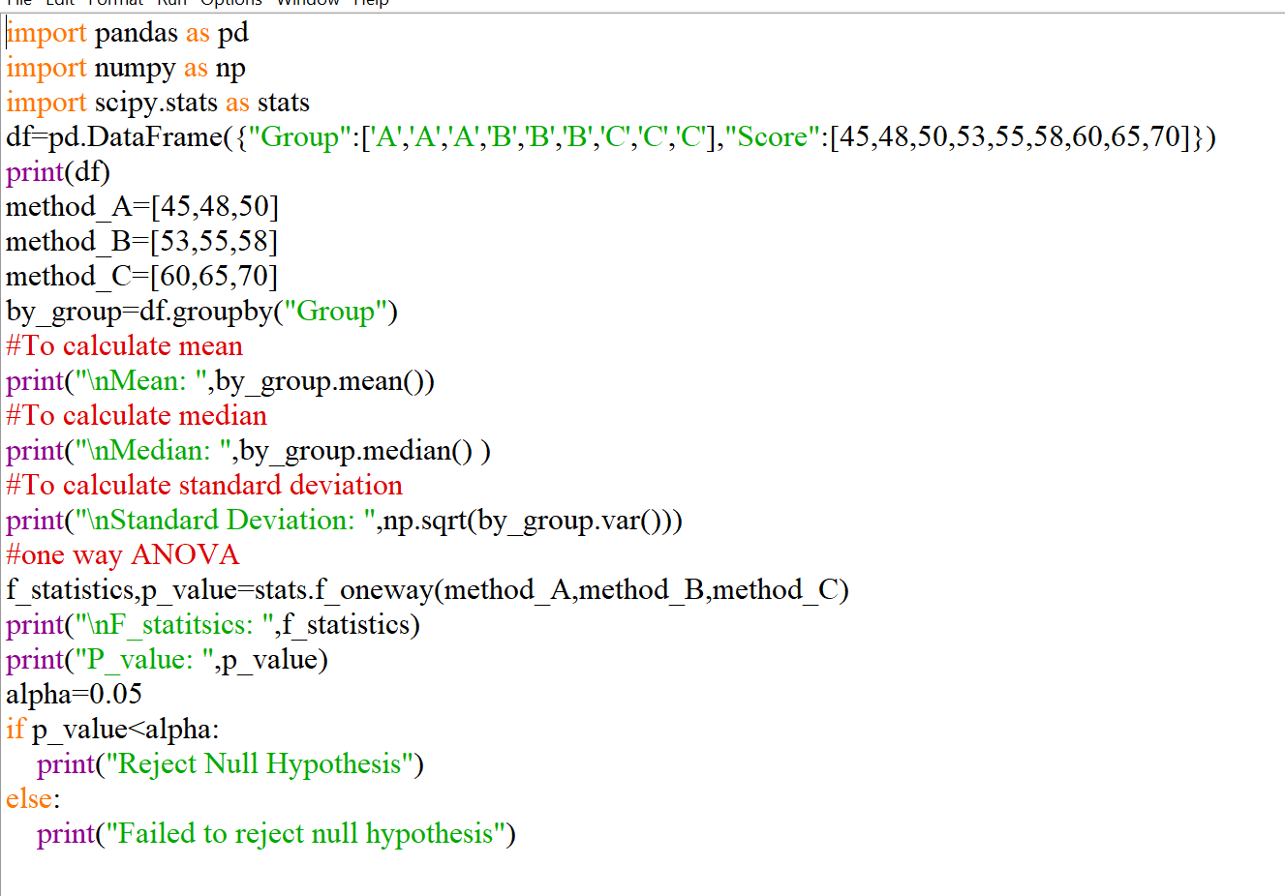

**Pictures of Output: (one or two pictures)**